# SUBMISSION

## Raedan AI Pty Ltd

Raedan AI Canberra-based data management specialists that assist organisations in insurance, government, banking and finance, publishing, media, and defence rely on expert.ai to turn language into data, analyse and understand complex documents, accelerate intelligent process automation, and improve decision-making.

**Andrew Smailes**

Andrew Smailes is a knowledgeable professional in the field of data management having 30+ years of experience developing data strategies, architectures, and solutions within Government Agencies. He has for many years been actively involved in DAMA, the Data Management Association and is a past National President and Canberra Branch Head. Andrew has presented in events, workshops and webinars addressing topics such as data governance, metadata, data architecture, data for AI, and Natural Language Understanding (NLU).

#### **Contact for further information:**

Andrew Smailes

CEO

Raedan AI

[andrew@raedanai.com](mailto:andrew@raedanai.com)

+61 414 911 923

# DATA AS FOUNDATION FOR RESPONSIBLE AI

## Introduction

In listening to the Safe and Responsible AI Virtual Town Hall, I was perplexed that there was little mention of the role data management plays as a foundation for Responsible AI.

Since the 1950s organisations have been collecting data for to improve productivity, either through better use of internal resources or by providing products and services that improved their customers productivity. Until the late 1990’s, systems would have been coded from scratch using a structured top-down methodology to ensure that all requirements were incorporated into the system design before coding started.

Since the 2000’s organisations have been buying systems rather than building them. Today organisation have purchase ERP, COTS and GOTS systems based on functional perspective and without consideration of interoperability and enterprise data needs. Important questions around the ethical, accuracy, structure and meaning of data have been secondary to IT delivery.

The drive for this has been that the ever-increasing capability of technology alone would achieve better outcomes. AI has become the latest of these capabilities and as the consultation paper says ‘Rich, large and quality data sets are a fundamental input to AI’.

The discussion around Responsible AI seems to start on the assumption that data scientists are dealing with data that is not fit for purpose. Which is true, Responsible AI was not a requirement consider in the purchase of any legacy system.

Unfortunately, today’s data strategies in Government and Commercial companies in Australia largely focus on implement functions defined in the DAMA Data Management Body of Knowledge (DAMA DMBoK) and not on use cases for data that will deliver strategic value to the organisation. Maybe this consultation might recommend Responsible AI should be part of every organisation’s data strategy?

However, there is one function of data management which I think is worth making a submission regarding Responsible AI. That is Reference Data Management (RDM) which is concern with managing data that categorises other data in a dataset.

On Page 8 of the Discussion Paper, it says:

*Algorithmic bias involves systematic or repeated decisions that privilege one group over another. Examples of discrimination against individuals based on race, sex or other protected categories are well publicised. These include:*

* *racial discrimination where AI has been used to predict recidivism which disproportionately targets minority groups*
* *educational grading algorithms favouring students in higher performing schools*
* *recruitment algorithms prioritising male over female candidates.*

What is being discussed here is Reference Data and the clarity and accuracy by which codes and definitions used to define the categories of race, sex, education status etc. Clearly if everyone was using the same codes, definitions, and categorisation logic then the quality of the data would improve.

For any dataset, 50% or more of the data will be reference data. Representation bias can stem from reference data leading to poor categorization of a sample. Asking an algorithm to be fair and ethical in processing of data adds complexity which would best be solved by getting the data right when it is collected, processed, and made available for data scientists.

## Nature of Data

As illustrated in Figure 1 below, there is no one size fits all to data management. When it is unpacked there are six different layers, each with its own characteristics. We propose that of these layers, reference data is the layer that needs to be closely managed to achieve responsible AI. It is in the definition and application of reference data in how race, education grading, sex and many other indicators where algorithmic bias can occur.

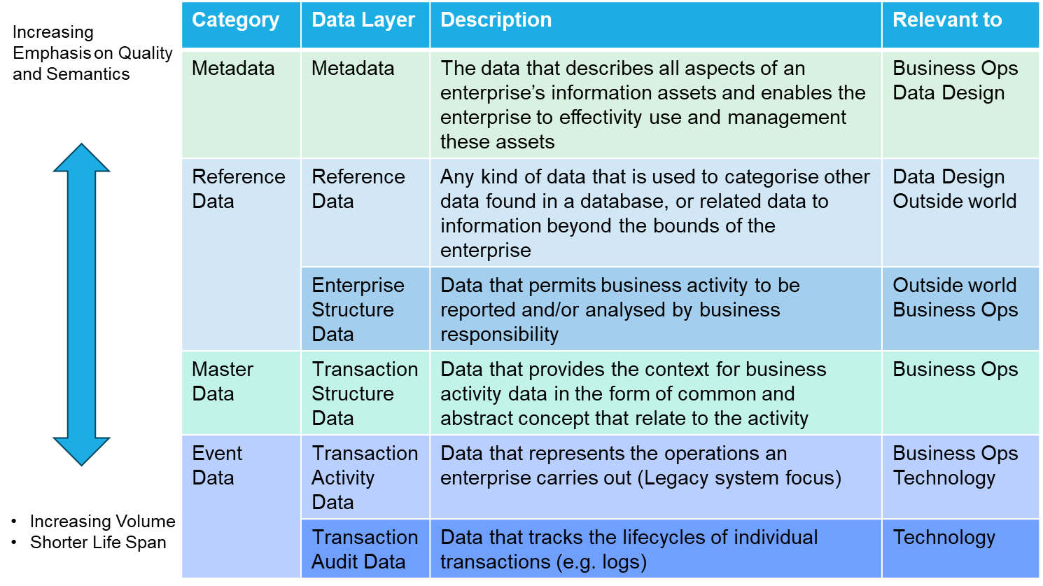

Figure The Layers of Data Architecture

The important concept to note is that reference data relates data to information beyond the bounds of the enterprise. If the external world is setting expectations, then any training data set should be aligned to those codes and the supporting definitions for those codes.

## Categories of Reference Data

Reference data also falls within seven or more categories. The seven most common are illustrated in Figure 1 below, however large, and complex organisations can find they have more to understand their business environments. Understanding the different Categories of Reference Data is important due to each having specific management issues.

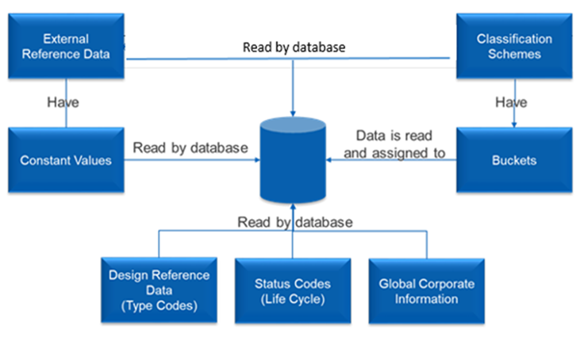

Figure - Categories of Reference Data

The categories of reference data illustrated are:

* External Reference Data – codes and descriptions managed by authoritative sources external to Defence. For example, Australian Statistical Geography, Exchange Rate data from the Reserve Bank of Australia.
* Design Reference Data – or Type Codes are tables of codes and values used to classify types and subtypes.
* Status codes – tables of codes and descriptions that describe states in the life cycle of a transaction or business process.
* Classification schemes – tables of code and descriptions that are used to categorise (or classify) other information in a database.
* Constant values – numeric and data attributes not managed by business processes. Usually effective for a period.
* Global data – data that is relevant to the whole of the enterprise as well as individual databases.
* Buckets – non-key attributes of reference data tables that store numeric data derived from transactions related to these reference tables.

## Benefits of Reference Data Management

The traditional view of reference data from the 1980s and 90s focused on operational applications that created and used reference data. The view was that Reference Data:

* Constrains the number of data values
* It provides standard abbreviations
* Saves screen and report “real estate”
* Reduces storage needs.

The traditional view focused on

* Structural Simplicity
* Transaction Applications
* Implementation.

Overtime a modern perspective of reference data has emerged as more applications became the consumers of reference data. Reference data can now be view as:

* Contextualises data as business information
* Represents concepts that the business controls
* Provides linkages to semantics and meaning of the codes.

The focus of reference data management today focuses on:

* Semantics and meaning
* Analytical and other applications, such as AI, that consume data
* Governance by business to ensure regulatory compliance.

Central management of Reference Data was seen as an important concept in the 1980s and 90s was organisation were building multiple systems using common Reference Data. The benefits of Reference Data Management are still valid today:

* **Consistency and Data Quality:** RDM ensures that reference values are standardised and consistent across different applications and data systems, reducing the chances of data discrepancies and improving overall data quality. This consistency is crucial when integrating data from multiple sources within a big data platform.
* **Common vocabulary:** enabling data and information exchange internal and external to the organisaton. Reference data sets are a single point of common data definition, enabling confidence in data exchange and the interpretation of data elements.
* **Accurate Reporting and Analysis:** By maintaining accurate and up-to-date reference data, organizations can generate reliable reports and conduct more accurate data analysis. This enables better decision-making and strategic planning based on trustworthy insights.
* **Efficient Data Integration:** Managing reference data centrally allows for easier data integration between various systems and applications. It streamlines data processing, reduces data conflicts, and simplifies the task of aggregating data from different functions within the organization.
* **Improved Data Governance:** Reference data management is a crucial component of data governance, ensuring that data is properly managed, accessed, and used according to established policies and rules. This helps maintain data integrity and security across the big data platform.
* **Cost Savings and Productivity**: Implementing a robust reference data management strategy can lead to cost savings by avoiding data-related errors, data redundancies, and the need for extensive data cleansing efforts. It also improves productivity by providing users with easy access to accurate reference data, saving time and effort in data handling.

## Reference Data Governance

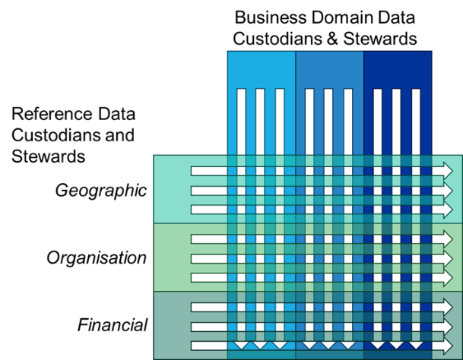Whilst many organisations today appoint Data Custodians and Data Stewards with responsibilities for data within different business domains, the need for specific governance of reference data is not recognised. For example, many business areas might use geographic reference data there is often no guidance or controls over what the boundaries represent and versioning of the data.

Figure 3 - Reference Data Governance

Reference Data Stewards focus on data across business domains providing what resembles data infrastructure that supports others.

Reference Data Stewards play an essential role in supporting AI projects with the support they need to ensure that there is conformity in the data they use for algorithms. The training datasets do conform to the modern requirements and reflect real-world expectations.

The role of a Reference Data Steward is to maintaining relationships with stakeholders and encourage the sharing of knowledge in reference data and how it is being used.

Executive Commitment is essential. Individual applications, databases and AI projects cannot be allowed to build and populate their reference data enables with inaccurate, inconsistent, and untimely use of reference data.

The benefits of an enterprise approach to reference data are:

* Reduction in duplication of effort of individuals maintaining reference data.
* Improved data quality savings effort in retraining if incorrect reference data is used
* Leads to the creation of a knowledge centre for reference data
* Enables an enterprise ability to manage risk and respond to change.

## Reference Data Discovery as a Service

All organisations need to be proactive in understanding RD needs and sources. A formal discovery process is required, and architectural models kept up to date. Many external sources offer some kind of subscription. This involves collaboration with procurement of costs, budget, and possible charge backs.

There is the need to maintain relationships with external sources, internal users and profiles maintained. Reference Data also needs some curation to ensure that it remains current provides value.

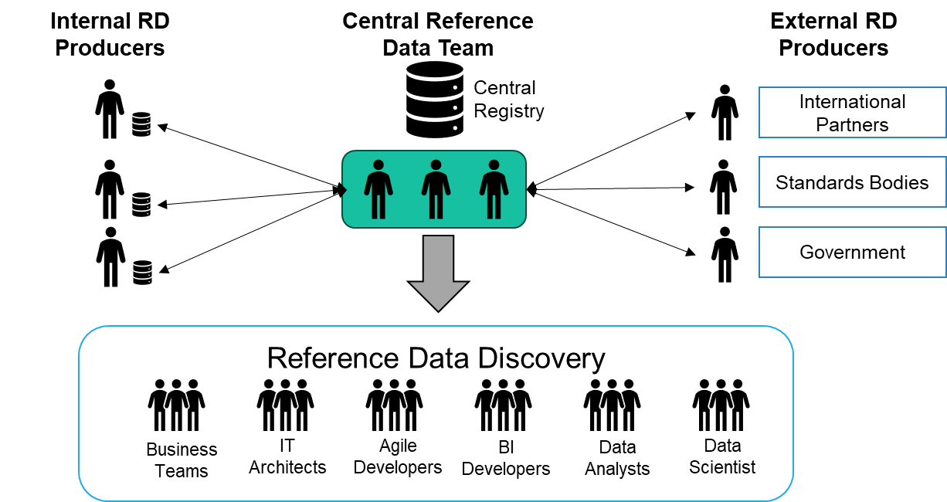

Figure - Reference Data As A Service

Given the multiple sources of Reference Data, Consumers need a central, consistent source of information about enterprise reference data. Poorly managed internal and external reference data impacts on productivity, use of data and data integrity.

Data Scientist can be both consumers and producers of reference data as they generate codes as part of the data preparation processes for AI Projects.

## Reference Data Role in Responsible AI

Today professional in the fields of Data Management, Records Management, Information Management, IT Architects, and Data Scientists work in silos. There is little attempt to collaborate, discuss issues and consider cross-discipline ways to boost each other’s productivity.

The textbook concept of RDM with centralised management and automatic distribution would be difficult to implement given the current legacy application landscape. Today the concept of a Reference Data Discovery Service does make sense when considering the need to share business knowledge of best practice across multiple stakeholders.

Many organisations are putting in place Data Quality frameworks, but don’t distinguish between the needs of different data types and without recognition of the importance of managing reference data to meet enterprise outcomes. If there was a common understanding of agreed categorisations, the standard codes to use, the definitions and alignment between the creators of data and the data science community working on AI Projects, then the potential for bias could be greatly reduced.

The Office of the National Data Commissioner (ONDC) is developing a Whole-of-Government data inventory. Many of the datasets will be reference datasets and all other datasets would contain some form of reference data. As the program moves to the consideration of sharing of data beyond research to operational purposes, including AI Projects, there will be a need to validate and standardise data to agreed codes and definitions.

In conclusion, the Safe and Responsible AI in Australia is dependent on the quality of data. This submission could have focus on the Data Architecture and Data Modelling as communication around what data is being used and how it is being used is essential to gaining agreement and validation that the algorithm is responsible.

Reference Data has a more practical application in ensure standards codes and definitions used are fit for purpose and free from defects of any kind.